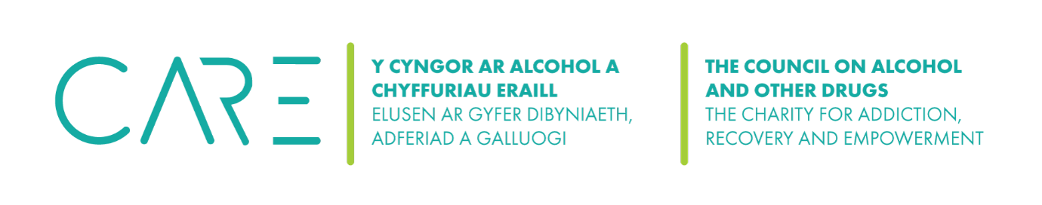
The Council on Alcohol and Other Drugs (CAOD) Complaints Policy
The CAOD provides fundraising services to support the emotional health and well-being of patients in Wales. It is considered crucial that these services are of a high standard and are sensitive to individual needs.
If you feel we have not reached the standards you expect, we want you to know what you can do and what will happen in such a case. We are always looking to improve, so it’s really useful to hear if we occasionally get things wrong so we can put them right.
The CAOD endeavours to treat all people who offer their complaints or feedback courteously and consider their input sensitively.

How do I complain?
Step 1
In the first instance, we ask the complainant to communicate, preferably in writing, their issue to the Chair of the CAOD. We ask that the complainant do this within one month of the situation occurring.
The Chair will attempt to come to a fair resolution with the complainant.
Step 2
If a resolution was not achieved in Step 1, the complainant can write to the Board of Trustees who will acknowledge the complaint within ten working days where possible and will investigate.
If the complexity of the case means that we expect it to take longer than 10 days, we will let you know as soon as we can. A written report will be compiled within one month and the complainant will be given the opportunity to explain the circumstances of the complaint. The Board of Trustees will consider the report and write to the complainant with their conclusions and any proposed course of action.
Records
A record of all complaints (verbal and written), reports and outcomes will be kept by the Chair.

Abusive, Harassing or Intimidating Behaviour
The Chair and Board of Trustees will do all in their power to protect trustees and volunteers from abusive, harassing, threatening and intimidating behaviour. In the case of such abuse being experienced during the reporting of a complaint, whether verbally or in writing, The CAOD will operate a Zero Tolerance Policy. The CAOD will endeavour to handle emotionally charged situations as sensitively as possible.

This policy was reviewed ……..

